**Fundamentals of Flight**

**Assignment 1**

**Task 1:**

I calculated those parameters assuming the layers between sea-level and tropopause and above 20 km are gradient layers and the layer between is isothermal layer. With the formulas from text book and lecture notes it is easy to get following answer.

|  |  |  |  |  |  |  |
| --- | --- | --- | --- | --- | --- | --- |
| Geopotential altitude (km) | Geometric altitude (km) | Temperature (K) | Pressure (kPa) | Density (kg/m^3) | Speed of sound (m/s) | viscosity (g/(ms) |
| 0,000 | 0,000 | 288,15 | 101,325 | 1,2250 | 340,3 | 1,789E-02 |
| 1,000 | 1,000 | 281,65 | 89,875 | 1,1116 | 336,4 | 1,758E-02 |
| 2,000 | 2,001 | 275,15 | 79,495 | 1,0065 | 332,5 | 1,726E-02 |
| 3,000 | 3,001 | 268,65 | 70,109 | 0,9091 | 328,6 | 1,694E-02 |
| 4,000 | 4,003 | 262,15 | 61,640 | 0,8191 | 324,6 | 1,661E-02 |
| 5,000 | 5,004 | 255,65 | 54,020 | 0,7361 | 320,5 | 1,628E-02 |
| 6,000 | 6,006 | 249,15 | 47,181 | 0,6597 | 316,4 | 1,595E-02 |
| 7,000 | 7,008 | 242,65 | 41,061 | 0,5895 | 312,3 | 1,561E-02 |
| 8,000 | 8,010 | 236,15 | 35,600 | 0,5252 | 308,1 | 1,527E-02 |
| 9,000 | 9,013 | 229,65 | 30,742 | 0,4663 | 303,8 | 1,492E-02 |
| 10,000 | 10,016 | 223,15 | 26,436 | 0,4127 | 299,5 | 1,457E-02 |
| 11,000 | 11,019 | 216,65 | 22,632 | 0,3639 | 295,1 | 1,422E-02 |
| 12,000 | 12,023 | 216,65 | 19,330 | 0,3108 | 295,1 | 1,422E-02 |
| 13,000 | 13,027 | 216,65 | 16,510 | 0,2655 | 295,1 | 1,422E-02 |
| 14,000 | 14,031 | 216,65 | 14,102 | 0,2268 | 295,1 | 1,422E-02 |
| 15,000 | 15,035 | 216,65 | 12,045 | 0,1937 | 295,1 | 1,422E-02 |
| 16,000 | 16,040 | 216,65 | 10,287 | 0,1654 | 295,1 | 1,422E-02 |
| 17,000 | 17,046 | 216,65 | 8,787 | 0,1413 | 295,1 | 1,422E-02 |
| 18,000 | 18,051 | 216,65 | 7,505 | 0,1207 | 295,1 | 1,422E-02 |
| 19,000 | 19,057 | 216,65 | 6,410 | 0,1031 | 295,1 | 1,422E-02 |
| 20,000 | 20,063 | 216,65 | 5,475 | 0,0880 | 295,1 | 1,422E-02 |
| 21,000 | 21,070 | 217,65 | 4,683 | 0,0750 | 295,7 | 1,427E-02 |
| 22,000 | 22,076 | 218,65 | 4,008 | 0,0639 | 296,4 | 1,433E-02 |
| 23,000 | 23,084 | 219,65 | 3,434 | 0,0545 | 297,1 | 1,438E-02 |
| 24,000 | 24,091 | 220,65 | 2,944 | 0,0465 | 297,8 | 1,444E-02 |
| 25,000 | 25,099 | 221,65 | 2,526 | 0,0397 | 298,5 | 1,449E-02 |

Here follows the plot of radios of varies parameters in ISA condition.

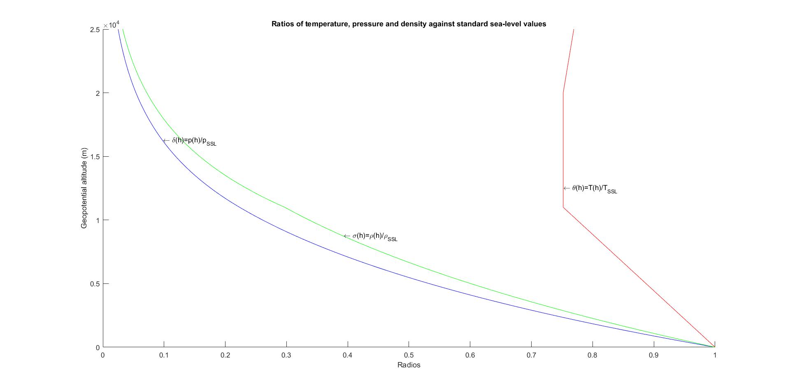**Task 2:**

For 1,00 kg/m3 and 0,80 kg/m3 there are only one altitude that corresponds to those densities. But for other densities there are many altitudes within these ranges. So I picked those altitudes with the minimum error.

|  |  |  |
| --- | --- | --- |
| Geopotential altitude (m) | Geometric altitude (m) | Density (kg/m^3) |
| 2064 | 2065 | 1,00 |
| 4223 | 4226 | 0,80 |
| 6845 | 6852 | 0,6 |
| 10251 | 10268 | 0,4 |
| 14796 | 14831 | 0,2 |
| 19192 | 19250 | 0,1 |

**Task 3:**

The atmosphere status in arctic weather is calculated in the same method as in the first task. I calculated the density with the ideal gas law with the specific gas constant of air as known. The tropopause I got is located at 8,5 km which is the row with double border line.

|  |  |  |  |  |
| --- | --- | --- | --- | --- |
| Geopotential altitude (km) | Geometric altitude (km) | Temperature (K) | Pressure (kPa) | Density (kg/m^3) |
| 0,000 | 0,000 | 252,15 | 100,000 | 1,3816 |
| 0,500 | 0,500 | 250,44 | 93,429 | 1,2996 |
| 1,000 | 1,000 | 248,74 | 87,248 | 1,2219 |
| 1,500 | 1,500 | 247,03 | 81,439 | 1,1484 |
| 2,000 | 2,001 | 245,33 | 75,980 | 1,0789 |
| 2,500 | 2,501 | 243,62 | 70,852 | 1,0131 |
| 3,000 | 3,001 | 241,91 | 66,038 | 0,9510 |
| 3,500 | 3,502 | 240,21 | 61,521 | 0,8922 |
| 4,000 | 4,003 | 238,50 | 57,283 | 0,8367 |
| 4,500 | 4,503 | 236,80 | 53,311 | 0,7843 |
| 5,000 | 5,004 | 235,09 | 49,588 | 0,7348 |
| 5,500 | 5,505 | 233,39 | 46,100 | 0,6881 |
| 6,000 | 6,006 | 231,68 | 42,835 | 0,6441 |
| 6,500 | 6,507 | 229,97 | 39,780 | 0,6026 |
| 7,000 | 7,008 | 228,27 | 36,922 | 0,5635 |
| 7,500 | 7,509 | 226,56 | 34,250 | 0,5266 |
| 8,000 | 8,010 | 224,86 | 31,754 | 0,4920 |
| 8,500 | 8,511 | 223,15 | 29,423 | 0,4593 |
| 9,000 | 9,013 | 223,15 | 27,254 | 0,4255 |
| 9,500 | 9,514 | 223,15 | 25,246 | 0,3941 |
| 10,000 | 10,016 | 223,15 | 23,386 | 0,3651 |
| 10,500 | 10,517 | 223,15 | 21,662 | 0,3382 |
| 11,000 | 11,019 | 223,15 | 20,066 | 0,3133 |
| 11,500 | 11,521 | 223,15 | 18,587 | 0,2902 |
| 12,000 | 12,023 | 223,15 | 17,218 | 0,2688 |
| 12,500 | 12,525 | 223,15 | 15,949 | 0,2490 |
| 13,000 | 13,027 | 223,15 | 14,774 | 0,2306 |
| 13,500 | 13,529 | 223,15 | 13,685 | 0,2136 |
| 14,000 | 14,031 | 223,15 | 12,677 | 0,1979 |
| 14,500 | 14,533 | 223,15 | 11,742 | 0,1833 |
| 15,000 | 15,035 | 223,15 | 10,877 | 0,1698 |

**Task 4:**

This task is similar to the third task. So we have the following table.

|  |  |  |  |  |
| --- | --- | --- | --- | --- |
| Geopotential altitude (km) | Geometric altitude (km) | Temperature (K) | Pressure (kPa) | Density (kg/m^3) |
| 0,000 | 0,000 | 307,15 | 100,000 | 1,1342 |
| 0,500 | 0,500 | 303,11 | 94,556 | 1,0867 |
| 1,000 | 1,000 | 299,08 | 89,341 | 1,0406 |
| 1,500 | 1,500 | 295,04 | 84,348 | 0,9959 |
| 2,000 | 2,001 | 291,00 | 79,572 | 0,9526 |
| 2,500 | 2,501 | 286,96 | 75,005 | 0,9105 |
| 3,000 | 3,001 | 282,93 | 70,641 | 0,8698 |
| 3,500 | 3,502 | 278,89 | 66,473 | 0,8303 |
| 4,000 | 4,003 | 274,85 | 62,496 | 0,7921 |
| 4,500 | 4,503 | 270,82 | 58,703 | 0,7551 |
| 5,000 | 5,004 | 266,78 | 55,089 | 0,7194 |
| 5,500 | 5,505 | 262,74 | 51,647 | 0,6848 |
| 6,000 | 6,006 | 258,71 | 48,372 | 0,6514 |
| 6,500 | 6,507 | 254,67 | 45,257 | 0,6191 |
| 7,000 | 7,008 | 250,63 | 42,299 | 0,5879 |
| 7,500 | 7,509 | 246,59 | 39,490 | 0,5579 |
| 8,000 | 8,010 | 242,56 | 36,826 | 0,5289 |
| 8,500 | 8,511 | 238,52 | 34,302 | 0,5010 |
| 9,000 | 9,013 | 234,48 | 31,911 | 0,4741 |
| 9,500 | 9,514 | 230,45 | 29,651 | 0,4482 |
| 10,000 | 10,016 | 226,41 | 27,514 | 0,4233 |
| 10,500 | 10,517 | 222,37 | 25,497 | 0,3994 |
| 11,000 | 11,019 | 218,34 | 23,596 | 0,3765 |
| 11,500 | 11,521 | 214,30 | 21,804 | 0,3544 |
| 12,000 | 12,023 | 210,26 | 20,118 | 0,3333 |
| 12,500 | 12,525 | 206,22 | 18,534 | 0,3131 |
| 13,000 | 13,027 | 202,19 | 17,046 | 0,2937 |
| 13,500 | 13,529 | 198,15 | 15,652 | 0,2752 |
| 14,000 | 14,031 | 198,15 | 14,359 | 0,2524 |
| 14,500 | 14,533 | 198,15 | 13,173 | 0,2316 |
| 15,000 | 15,035 | 198,15 | 12,085 | 0,2125 |

**Task 5:**

Following graphs show the pressure, temperature and density change in different atmosphere conditions. They have some differences.

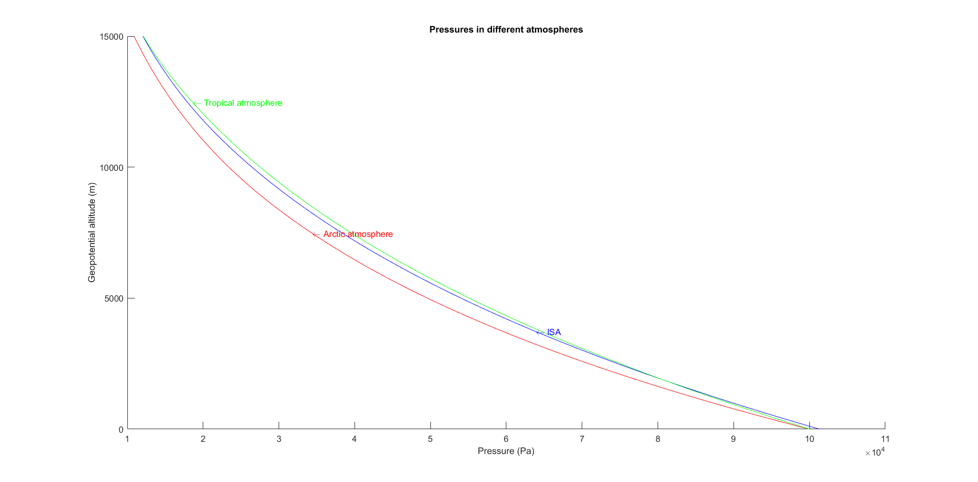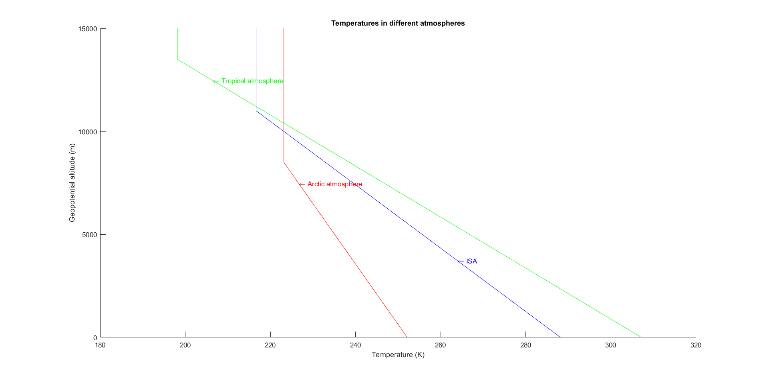

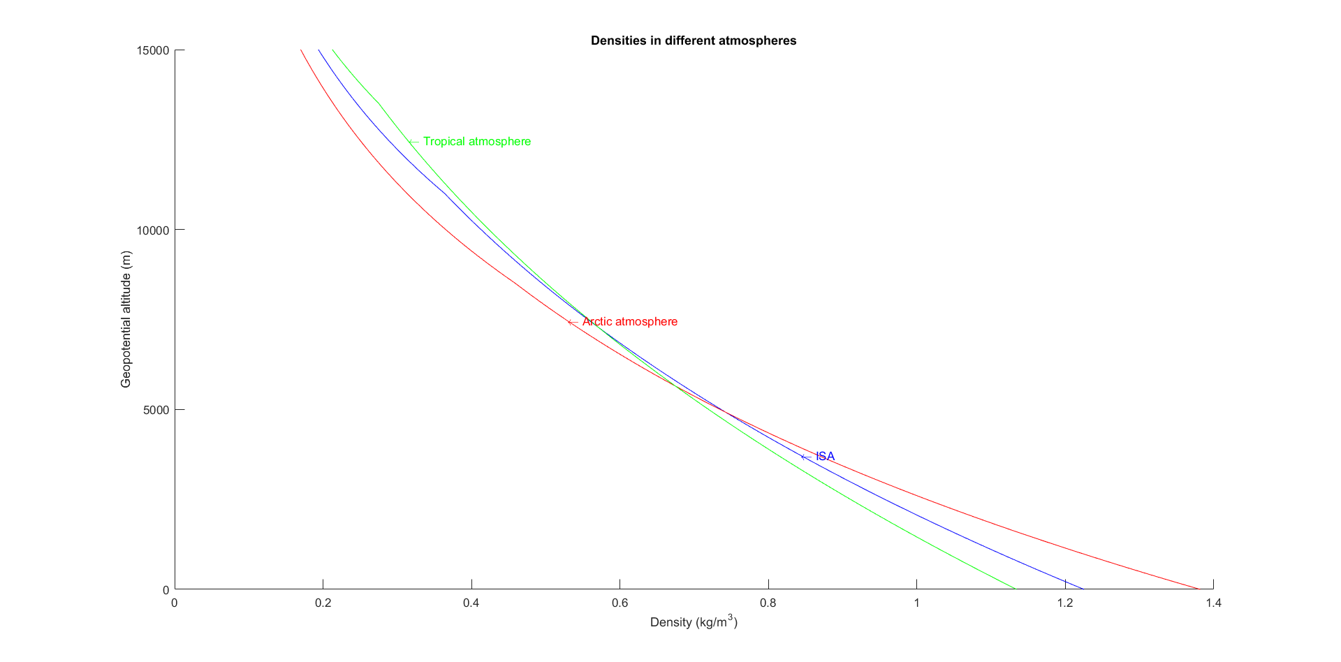

**Task 6:**

|  |  |  |  |
| --- | --- | --- | --- |
|  | Geopotential altitude (m) | Geometric altitude (m) | FLXXX |
| Arctic | 9868 | 9883 | FL325 |
| ISA | 10363 | 10380 | FL340 |
| Tropic | 10762 | 10780 | FL355 |

Here we have the table shows the flight level and the correspondent geopotential and geometric altitude. There is an almost 1km’s difference between different places but with the same air pressure. This shows that to use flight level as reference of flight altitude is a good way of avoid collision.

**Task 7:**

The temperature increases with the altitude in this atmosphere with inversion until 1,6km. So the pressure decreases faster while the density decreases slower. The speed of sound increases as well with altitude. These are the differences between this atmosphere and the ISA.

|  |  |  |  |  |
| --- | --- | --- | --- | --- |
| Geopotential altitude (m) | Geometric altitude (m) | Temperature (K) | Pressure (kPa) | Density (kg/m^3) |
| 0 | 0 | 258,15 | 101,325 | 1,3673 |
| 200 | 200 | 258,95 | 98,682 | 1,3276 |
| 400 | 400 | 259,75 | 96,117 | 1,2891 |
| 600 | 600 | 260,55 | 93,625 | 1,2518 |
| 800 | 800 | 261,35 | 91,205 | 1,2157 |
| 1000 | 1000 | 262,15 | 88,856 | 1,1808 |
| 1200 | 1200 | 262,95 | 86,573 | 1,1469 |
| 1400 | 1400 | 263,75 | 84,356 | 1,1142 |
| 1600 | 1600 | 264,55 | 82,202 | 1,0824 |
| 1800 | 1801 | 263,67 | 80,103 | 1,0583 |
| 2000 | 2001 | 262,78 | 78,050 | 1,0347 |
| 2200 | 2201 | 261,90 | 76,044 | 1,0115 |
| 2400 | 2401 | 261,02 | 74,082 | 0,9887 |
| 2600 | 2601 | 260,14 | 72,165 | 0,9664 |
| 2800 | 2801 | 259,25 | 70,291 | 0,9445 |
| 3000 | 3001 | 258,37 | 68,460 | 0,9230 |

Declaration: Here I promise that all the work is done by myself alone without help from other students.